Mail order Catalogue

SPRING 2021
N, 3mm, H0, 00 & 0 scales

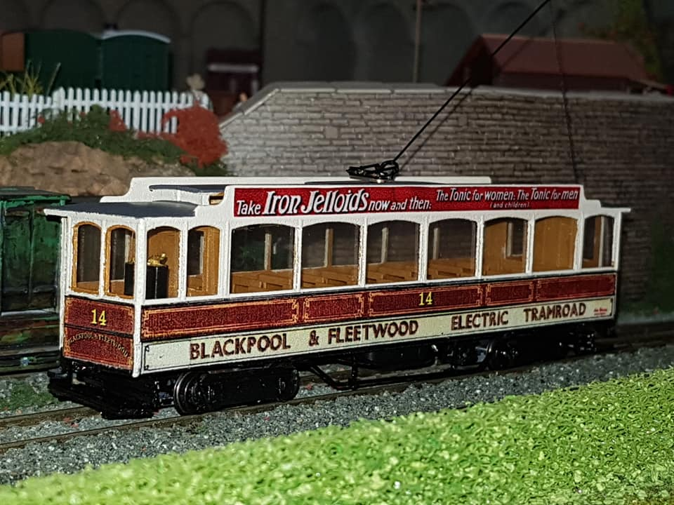

Available exclusively from:
East Lancs Model Tramway Supplies
Mr. J. D. Whitehouse
14 Buttermere Road,
Burnley, Lancashire, BB10 4HU
Tel. 01282 436802 (evenings)
Mob. 07840 707653
www.themodeltramshop.com
email sales.elmts@gmail.com

Contacting us
We can be contacted at the address above, either by letter, email, phone or text.
Please note the following:
CMT is not John’s main job so he can usually only be contacted at the following times:
Phone: Evenings 6 – 9 pm.
Phone – leave a voicemail: Anytime from 8 – 10pm. Answerphone messages will be dealt with as quickly as possible, but please allow up to 28 days for a response to ANY communication.
Email, text, watsapp: Anytime and I will answer as soon as I can .

Postage:
Please add £6.00 per order.
Overseas postage usually charged at £10.00

TERMS & CONDITIONS
Payment methods
We accept the following payment methods: Cash, cheque, Postal order, paypal, card or bank transfer.
Cheques should be made payable to East Lancs Model Tramway Supplies and in £ sterling, drawn on a British bank.
Cash in £ sterling also accepted but sent through the post at your own risk.
Paypal - Please ask us to send a payment request or you can pay direct to the paypal account at john.whitehouse1977@gmail.com
We accept card payments via paypal here which is a mobile phone app. Please phone with card details or send with order.

All prices are correct at time of publication. We reserve the right to change prices without notice.

Refunds/exchange
Goods will be refunded or exchanged free of charge if they are faulty or damaged.
Unwanted goods cannot be returned. All purchases are special orders and therefore non –refundable except for faulty or damaged items.

Corporation Model Trams kits
3d printed bodies with additional items.
As these are printed to order please allow up to 60 days from ordering. We will advise if this will be longer.
As with any model body or kit they will require additional work before painting. Occasionally the bodies will come with orientation marks where they have been printed. This is a part of the printing process and is not a defect, a filler primer or thin layer of filler will correct this.

Note:
All bogie car floor units consist of seating unit and integral mechanism frame. Most also have the platforms and fenders attached.
These units are printed in WSF or WSF polished and are of a rougher (cheaper) texture than the main kits. They can be smoothed off with filler primer if desired.
4 wheel cars do not have lower deck seating due to the height of the traction units.

Not all items are currently available and due to production and pricing changes some may be cancelled. Please enquire.

DUE TO THE NATURE OF 3D PRINTING, LONG LEAD TIMES FOR BOGIE PARTS AND ADD ON PACKS SOMETIMES REQUIRING CASTING PLEASE ALLOW A MINIMUM 28 DAYS FOR ORDERS, BUT THIS MAY BE LONGER AT TIMES.

Pricing
All prices are based on current exchange rate and current Printers prices therefore ALL models are Price on Application before ordering, hence the general catalogue is now unpriced.

Direct ordering
You can also order some of the bodies direct from Shapeways and imaterialise. This is easier and cheaper than ordering from us. Add ons etc can be ordered from us.

https://www.shapeways.com/shops/corporationmodeltrams?li=pb

https://i.materialise.com/en/shop/designer/corporationmodeltrams

Tram models | Scales available
Generic British outline
3d body
Open top 3 window 4 wheel, reversed stairs | 00, N
Open top 3 window, reversed stairs with double height decency panel | 00, N
Chassis unit with platforms, stairs, Vario holder | 00
Platforms/stairs on chassis | N
Accrington
Bogie car no. 38 – 41  Includes 3d body, roof and integrated bogie unit with platforms etc, etched seats, trolley pole kit, lifeguards, bogie sides and some decals. | 00
Blackpool – 1885 – 1932 (pre-Streamline period)
Marton Box Open top  Includes 3d body and platforms etc, etched seats, trolley pole, add on kit with trucksides etc, some decals. | 00, 3mm (body only)
Works Tram 2 (ex Marton Box 33)  Includes 3d body and platforms etc, add on kit, trolley pole. | 00
Blackpool & Fleetwood Rack
Includes 3d lower body and integrated chassis, stanchions (plastic strip), seats, bogie sides, roof, etched detail, trolley pole kit. This model is more of a Traditional kit which requires assembly.
Original condition | 00
Early 1920s condition | 00
Late 1920s condition with route letter box | 00
BCT 1930s condition with full destination box | 00
Blackpool & Fleetwood Box car
3d body

6 window original condition | 00, N
6 window BCT early 20s condition | 00
6 window late 20s condition with route letter box | 00, N
6 window 1930s condition | 00
8 window original condition | 00, N
8 window BTS early 20s condition | 00
8 window late 20s condition with route letter box | 00, N
8 window 1930s condition | 00
New Box original condition | 00, N
New Box BCT early 20s condition | 00, N
New Box late 20s condition with route letter box | 00
New Box 1930s condition | 00
Works 114 (1936 – 45) | 00
Works 5 | 00
Box 40 1960s | 00
Box 40 1980s | 00
Box 40 late 90s | 00
Box 40 current condition | 00
6 window box chassis/interior | 00
8 window box chassis/interior | 00
New box chassis/interior | 00
Add on pack | 00
Glasshouse
3d body
Early 20s 116/117 | 00
Early 20s 119-121 | 00
Late 20s 116/117 | 00, N
Late 20s 119-121 | 00
Brill bogie version floor/chassis/interior | 00
Rebuilt bogie version floor/chassis/interior | 00
add on detail pack, trolley pole kit, decals | 00
Pantograph
3d body
As delivered | 00
1930 full destination box | 00
1934 onwards double tail lights and full destination box | 00
Later post 1936 condition with ‘streamlined’ destination box as 167 current preserved condition | 00,N
Interior with integrated chassis | 00
Add on detail pack, etch lifeguards, tower etc, trolley pole kit | 00
English Electric loco  3d body | 0, 00, N
Add on pack, trolley pole kit | 00
Standard  3d body, roof, upper deck and chassis/platforms. | 2023
40 in balcony condition as last running on Marton and first preserved condition | 2023
48 as last running on Marton and preserved condition | 2023
1933 onwards – the Streamline era to 2011
Brush railcar 624/748/259 – permanent way vehicle  3d body | 00, N, Z
‘Long John’ Railcrane  Includes 3d body, crane, trucksides | 00
Brush railcar
3d body, interior/chassis and etched detail
Original 1937 condition with open sun roofs
Original 1937 condition with closed roof
636 with bogie cut outs | 00, N
1970s (621) with twin indicators but no roof lights | 00, N
Generic 70s – 90s Brush with square windows and no rooflights | 00, N
Late 80s/ Early 90s windscreen and OMO hopper windows (622/25/27/32/33) | 00
Later 90s cab windscreen and OMO hopper windows | 00
Late 80s/ Early 90s windscreen and full OMO windows (634/37) | 00
Later 90s cab windscreen and full OMO windows | 00
623 in current preserved condition | 00
621 with square hoppers | 00, N
621 with square hoppers and later 90s windscreen | 00
630/31 90s rebuild and 630 preserved condition | 00, N
626 90s refurbished | 00, N
631 preserved hybrid condition | 00
Add on pack - tower, etch lifeguards & bumpers, trucksides, | 00, N
Sun saloon/cattle truck  3d body, interior/chassis and etched tower etc | 2023
Marton VAMBAC  3d body, interior/chassis and etched tower etc. | 2023
Original beaded condition | 2023
Later reduced beading condition | 2023
No.s 13 and 18 with removed centre destination box. | 2023
Twin Car Motor
3d body
As built (double ended) | 00, N
Permanently coupled 671/677 | 00, N
Permanently coupled 672/674 | 00, N
Permanently coupled 673 | 00, N
Permanently coupled 675 | 00, N
Permanently coupled 676 | 00, N
Floor and integrated chassis – double ended version | 00
Floor and integrated chassis – permanently coupled version | 00
Add on pack - Tower, lifeguards, trucksides, | 00, N
Twin Car Trailer
Includes 3d body
As built | 00, N
Permanently coupled 681 – 685, 687 | 00, N
Permanently coupled 686 | 00, N
Interior and integrated chassis – original | 00
Interior and integrated chassis – permanently coupled | 00
Add on pack - ifeguards, trucksides | 00, N
Ex-Towing Railcoaches
3d body
1970s/80s | 00, N
Mid 1990s 678 | 00, N
Early- mid 90s 679 | 00, N
late 90s 679 | 00, N
Post 2004 679 | 00, N
Post 1992 overhaul 680 | 00, N
Interior and integrated chassis | 00
Add on pack - tower, lifeguards, trucksides, | 00, N
Railcoach 264/611 ‘the plastic Tram’  Includes 3d body, interior with integrated chassis, | 00, N
Interior with integrated chassis | 00
Add on pack - tower, lifeguards, trucksides, | 00, N
Rebuilt Railcoach 618 ‘the coffin’
Includes 3d body
Original condition | 00, N
Later all windows with hoppers condition | 00, N
Interior with integrated chassis | 00
Add on pack - lifeguards, tower, trucksides | 00, N
OMO 1 – 13  3d body | 0, 00, N
Interior with integrated chassis | 00
Add on pack - tower, etch details, | 00, N
Jubilee 761
3d body
Original condition | 00, N
1990s flat cab rebuild | 0, 00, N
2000s with large destination box | 00
lifeguards, trucksides, | 00, N
Upper and lower deck (resin) | 00
Jubilee 762
3d body
Original condition | 00, N
1990s flat front rebuild | 00
1990s second rebuild | 00
Final preserved condition | 00, N
Lifeguards, trucksides, | 00, N
resin upper and lower decks, pantograph | 00
Centenary
3d body
641 original condition | 00, N
Production original condition | 0, 00, H0, N
Production mid 90s 2 headlight dash | 00
Later 90s 2 headlight dash | 00
641 rebuild | 00
642 rebuild | 00
648 current Heritage condition | 00
642 current Heritage condition | 00
Add on pack - tower, lifeguards, trucksides | 00, N
Windscreens | 00
Vanguard 619
Includes 3d body, tower, lifeguards, trucksides
Balloon
3d body
701 90s rebuild | N
711 90s rebuild | N
723 90s rebuild | N
Ex open top 90s pan no dome strip | N
Ex open top pan90s | N
Ex open top pan | N
Ex open top no dome strip | N
Ex open top | N
No arch and no roof lights (generic) | 0, 00
Roof arch, roof lights | 0, N
Arch no roof lights | 00
Princess Alice open top | N
Add on pack - Lifeguards, bumpers and trucksides | 00, N
Millennium flat front Balloon
Includes 3d body, trucksides
707 with original lights | 00
707 with later lights (also 709) | 00
709 | 00, N
718 | 00
724 | 00
707/709 with door pods | 00, N
Illuminated Trawler 737 – early condition before 2016 refurb.
Boat
Original style with no windscreens
Later style with 90s split windscreen
2011 – present ‘Heritage’ era
Western train 733/734  Includes 3d loco and trailer body | 00, N
Interiors with integrated chassis unit, pantograph tower, trolley base, cow catcher, lifeguards, pantograph, trucksides, decals | 00
Bolton 66, current preserved condition | 00, N
Bolton 66 class, Bolton condition bumpers | 00
Chassis with platform, stairs etc | 00
Platforms with stairs | N
Add on pack - lifeguards, seats, trolley pole | 00
Burnley
Works electric Loco  Includes 3d body, chassis unit with trucksides | 00
Works electric loco (snowplough version)  Includes 3d body, chassis unit with trucksides and snowplough | 00
Single deck 39 – 46  Includes 3d body, interior with integrated chassis, bogie sides, lifeguards, trolley pole kit | 00
Double deck
Open top bogie | 00
Bogie Windshield | 00
Bogie Balcony | 00
Bogie Balcony, higher balcony panel | 00
Add on pack - integrated chassis with platforms, stairs etc and etched lifeguards.
Glasgow
Cunarder
3d body
With roof lights | 00, N
With panelled roof | 00, N
Heaton Park Tramway
Stockport 5 in current preserved condition  Includes 3d body, chassis unit with platforms, handrails, lifeguards, trolley pole | 00
Howth
Cars 9 & 10  Includes 3d body, | 00
Blackpool condition with roof boxes | 00, N
chassis with platforms etc, | 00
Platforms with stairs | N
Add on pack - lifeguards, handrails, bogie sides | 00
Liverpool
Experimental Tram 757  Includes 3d body, interior with integrated chassis, detail parts – tower etc, trolley pole kit | 00, N
Lytham
UEC rebuilt crossbench 21 – 30  Includes 3d body, chassis with platforms, destination boxes, etched seats, lifeguards, handrails, trolley pole | 00
Cars 6, 9, 15 with high decency panels  Includes 3d body, chassis with platforms, etched seats, lifeguards, handrails, trolley pole | 00
Bogie car 55 ‘Big bertha’  Includes 3d body, roof, chassis unit with platforms, etched seats, lifeguards, trucksides, trolley pole kit | 00
Manx Electric Railway
3d body
Rack (based on amended Fleetwood 3d print) (kit) | 00
Winter saloon 21 (modified Fleetwood Box) | 00
Southend
Toastrack 40 – 43  Includes 3d lower body with integrated chassis, upper body with seats, bulkheads and roof etc, trucksides, trolley pole kit | 00
Bogie cars 65 – 67 ex Accrington  Includes 3d body, roof and chassis with platforms, etched seats, lifeguards, trucksides, trolley pole kit | 00
Wartime enclosed Toastrack.
Vienna
Type F double deck  3d body | 00, N
San Francisco
Peter Witt 3d body | H0, N
Integrated interior and chassis with trucksides | H0
Motorising units
Halling Vario RTR unit for Generic British, Lytham rack & open top, Stockport 5, Blackpool & Burnley electric loco | 00
Halling motorising kit for longer bogie cars – 2 geared bogies, motor, tube, wire | 00
Halling motorising kit for Accrington/Lytham/Southend and Howth bogie cars – one geared and one trailing bogie, motor, tube, wire | 00
Pair of Halling Doha type trailer bogies for Long John | 00
Blackpool Halling type power unit with 3d frame RTR for Blackpool trams without integrated chassis (plus Corgi diecast, Hadfield kits) | 00
Blackpool Centenary chassis – this is not a CMT product so requires a little work to get to fit | 00
Tomytec TM TR01 for Blackpool Streamline Trams | N
Tomytec TM TR04 for Blackpool Jubilee | N
Tomytec Tm TR05 for Blackpool Centenary and Coronation | N
NOTE
Tomytec mechanisms are not always in stock due to being batch produced. They can be obtained direct from Plaza Japan
Extras
Etched 3 bar upper deck handrails (can be trimmed to 1 or 2 bar)
Etched upper deck Handrails from Howth kit, can also be used with Burnley Trams
Etched generic dog gate (Fleetwood etc)
Etched English Electric/Brush lifeguards
Etched English Electric bumpers
Etched generic lifeguards
Etched Pantograph Tram set
Etched double seats (12)
Etched single seats (12)
Trolley pole kit
Open top Trolley Pole kit
Diamond Pantograph
Burnley Bogie Trucksides
Brill Trucksides (Burnley kit)
Brill EW trucksides (Burnley & Glasshouse)
Southend trucksides
Peter Witt trucksides
English Electric trucksides
Preston McGuire trucksides
Balloon upper deck (plastic) | 00
Balloon upper deck (resin) | N
Balloon complete interior (3d) | N
Roof advert boxes | 00, N
Bus Models
Gondola Bus | New 2022/3
Leyland PD full front | 2023

