Mail order Catalogue

SPRING 2023
N, 3mm, H0, 00 & 0 scales

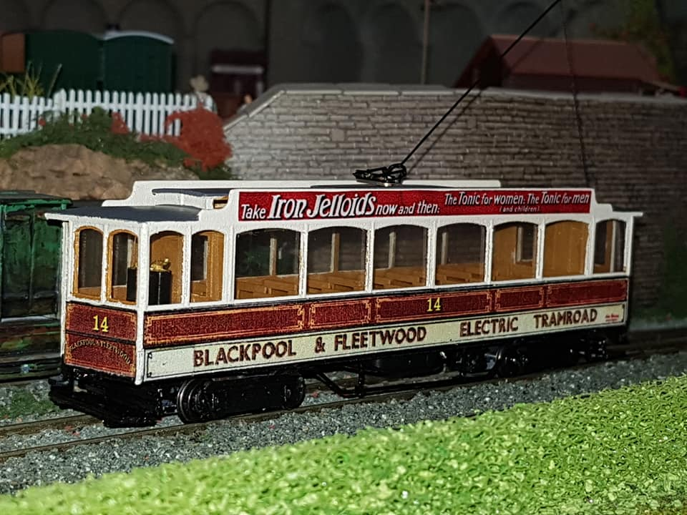

Available exclusively from:
East Lancs Model Tramway Supplies
Mr. J. D. Whitehouse
14 Buttermere Road,
Burnley, Lancashire, BB10 4HU
Tel. 01282 436802 (evenings)
Mob. 07840 707653
www.themodeltramshop.com
email sales.elmts@gmail.com

Contacting us
We can be contacted at the address above, either by letter, email, phone or text.
Please note the following:
CMT is not John’s main job so he can usually only be contacted at the following times:
Phone: Evenings 6 – 9 pm.
Phone – leave a voicemail: Anytime from 8 – 10pm. Answerphone messages will be dealt with as quickly as possible, but please allow up to 28 days for a response to ANY communication.
Email, text, watsapp: Anytime and I will answer as soon as I can .

Postage:
Please add £6.00 per order.
Overseas postage usually charged at £10.00

TERMS & CONDITIONS
Payment methods
We accept the following payment methods: Cash, cheque, Postal order, paypal, card or bank transfer.
Cheques should be made payable to East Lancs Model Tramway Supplies and in £ sterling, drawn on a British bank.
Cash in £ sterling also accepted but sent through the post at your own risk.
Paypal - Please ask us to send a payment request or you can pay direct to the paypal account at john.whitehouse1977@gmail.com

Refunds/exchange
Goods will be refunded or exchanged free of charge if they are faulty or damaged.
Unwanted goods cannot be returned. All purchases are special orders and therefore non –refundable except for faulty or damaged items.

Corporation Model Trams kits
3d printed bodies with additional items.
As these are printed to order please allow up to 60 days from ordering. We will advise if this will be longer.
As with any model body or kit they will require additional work before painting. Occasionally the bodies will come with orientation marks where they have been printed. This is a part of the printing process and is not a defect, a filler primer or thin layer of filler will correct this.

Note:
All bogie car floor units consist of seating unit and integral mechanism frame. Most also have the platforms and fenders attached.
These units are printed in WSF or WSF polished and are of a rougher (cheaper) texture than the main kits. They can be smoothed off with filler primer if desired.
4 wheel cars do not have lower deck seating due to the height of the traction units.

Not all items are currently available and due to production and pricing changes some may be cancelled. Please enquire.

DUE TO THE NATURE OF 3D PRINTING, LONG LEAD TIMES FOR BOGIE PARTS AND ADD ON PACKS SOMETIMES REQUIRING CASTING PLEASE ALLOW A MINIMUM 28 DAYS FOR ORDERS, BUT THIS MAY BE LONGER AT TIMES.

Pricing
All prices are based on current exchange rate and current Printers prices therefore ALL models are Price on Application before ordering, hence the general catalogue is now unpriced.

Direct ordering
You can also order some of the bodies direct from Shapeways and imaterialise. This is easier and cheaper than ordering from us. Add ons etc can be ordered from us.

https://www.shapeways.com/shops/corporationmodeltrams?li=pb

https://i.materialise.com/en/shop/designer/corporationmodeltrams

Scale
Most of the models are available to order in N, H0, 00 and 0 scale. Please enquire before ordering as there are a few exceptions.
We will also advise which materials are available.

**Illuminated Trams do not contain working lights.

Tram models
Generic British outline
3d body
Open top 3 window 4 wheel, reversed stairs
Open top 3 window, reversed stairs with double height decency panel
Chassis unit with platforms, stairs, Vario holder
Platforms/stairs on chassis
Accrington
Bogie car no. 38 – 41
Includes 3d body, roof and integrated bogie unit with platforms etc, etched seats, trolley pole kit, lifeguards, bogie sides and some decals.
Blackpool – 1885 – 1932 (pre-Streamline period)
Marton Box Open top
Includes 3d body and platforms etc, etched seats, trolley pole, add on kit with trucksides etc, some decals.
Works Tram 2 (ex Marton Box 33)
Includes 3d body and platforms etc, add on kit, trolley pole.
Blackpool & Fleetwood Rack
Includes 3d lower body and integrated chassis, stanchions (plastic strip), seats, bogie sides, roof, etched detail, trolley pole kit. This model is more of a Traditional kit which requires assembly.
Original condition
Early 1920s condition
Late 1920s condition with route letter box
BCT 1930s condition with full destination box
Blackpool & Fleetwood Box car
3d body

6 window original condition
6 window BCT early 20s condition
6 window late 20s condition with route letter box
6 window 1930s condition
8 window original condition
8 window BTS early 20s condition
8 window late 20s condition with route letter box
8 window 1930s condition
New Box original condition
New Box BCT early 20s condition
New Box late 20s condition with route letter box
New Box 1930s condition
Works 114 (1936 – 45)
Works 5
Box 40 1960s
Box 40 1980s
Box 40 late 90s
Box 40 current condition
6 window box chassis/interior
8 window box chassis/interior
New box chassis/interior
Add on pack
Glasshouse
3d body
Early 20s 116/117
Early 20s 119-121
Late 20s 116/117
Late 20s 119-121
Brill bogie version floor/chassis/interior
Rebuilt bogie version floor/chassis/interior
add on detail pack, trolley pole kit, decals
Pantograph
3d body
As delivered
1930 full destination box
1934 onwards double tail lights and full destination box
Later post 1936 condition with ‘streamlined’ destination box as 167 current preserved condition
Interior with integrated chassis
Add on detail pack, etch lifeguards, tower etc, trolley pole kit
English Electric loco
3d body
Add on pack, trolley pole kit
Standard
3d body, roof, upper deck and chassis/platforms.
40 in balcony condition as last running on Marton and first preserved condition
48 as last running on Marton and preserved condition
We have sufficient files for any Standard variation possible. Please contact us with your chosen tram and condition. This includes both version of works Tram 753.
1933 onwards – the Streamline era to 2011
Brush railcar 624/748/259 – permanent way vehicle
3d body
‘Long John’ Railcrane
Includes 3d body, crane, trucksides
Brush railcar
3d body, interior/chassis and etched detail
Original 1937 condition with open sun roofs
Original 1937 condition with closed roof
636 with bogie cut outs
1970s (621) with twin indicators but no roof lights
Generic 70s – 90s Brush with square windows and no rooflights
Late 80s/ Early 90s windscreen and OMO hopper windows (622/25/27/32/33)
Later 90s cab windscreen and OMO hopper windows
Late 80s/ Early 90s windscreen and full OMO windows (634/37)
Later 90s cab windscreen and full OMO windows
623 in current preserved condition
621 with square hoppers
621 with square hoppers and later 90s windscreen
630/31 90s rebuild and 630 preserved condition
626 90s refurbished
631 preserved hybrid condition
Add on pack - tower, etch lifeguards & bumpers, trucksides,
Sun saloon/cattle truck
3d body, interior/chassis and etched tower etc
Marton VAMBAC
3d body, interior/chassis and etched tower etc.
Original beaded condition
Later reduced beading condition
No.s 13 and 18 with removed centre destination box.
Twin Car Motor
3d body
As built (double ended)
Permanently coupled 671/677
Permanently coupled 672/674
Permanently coupled 673
Permanently coupled 675
Permanently coupled 676
Floor and integrated chassis – double ended version
Floor and integrated chassis – permanently coupled version
Add on pack - Tower, lifeguards, trucksides,
Twin Car Trailer
Includes 3d body
As built
Permanently coupled 681 – 685, 687
Permanently coupled 686
Interior and integrated chassis – original
Interior and integrated chassis – permanently coupled
Add on pack - ifeguards, trucksides
Ex-Towing Railcoaches
3d body
1970s/80s
Mid 1990s 678
Early- mid 90s 679
late 90s 679
Post 2004 679
Post 1992 overhaul 680
Interior and integrated chassis
Add on pack - tower, lifeguards, trucksides,
Railcoach 264/611 ‘the plastic Tram’
Includes 3d body, interior with integrated chassis,
Interior with integrated chassis
Add on pack - tower, lifeguards, trucksides,
Rebuilt Railcoach 618 ‘the coffin’
Includes 3d body
Original condition
Later all windows with hoppers condition
Interior with integrated chassis
Add on pack - lifeguards, tower, trucksides
OMO 1 – 13
3d body
Interior with integrated chassis
Add on pack - tower, etch details,
Jubilee 761
3d body
Original condition
1990s flat cab rebuild
2000s with large destination box
lifeguards, trucksides,
Upper and lower deck (resin)
Jubilee 762
3d body
Original condition
1990s flat front rebuild
1990s second rebuild
Final preserved condition
Lifeguards, trucksides,
resin upper and lower decks, pantograph
Centenary
3d body
641 original condition
Production original condition
Production mid 90s 2 headlight dash
Later 90s 2 headlight dash
641 rebuild
642 rebuild
648 current Heritage condition
642 current Heritage condition
Add on pack - tower, lifeguards, trucksides
Windscreens
Vanguard 619
Includes 3d body, tower, lifeguards, trucksides
Balloon
3d body
701 90s rebuild
711 90s rebuild
723 90s rebuild
Ex open top 90s pan no dome strip
Ex open top pan90s
Ex open top pan
Ex open top no dome strip
Ex open top
No arch and no roof lights (generic)
Roof arch, roof lights
Arch no roof lights
Princess Alice open top
Add on pack - Lifeguards, bumpers and trucksides
Millennium flat front Balloon
Includes 3d body, trucksides
707 with original lights
707 with later lights (also 709)
709
718
724
707/709 with door pods
Illuminated Trams
Illuminated Trawler 737 – early condition before 2016 refurb.
Hovertram
Western Tran 80s/90s condition
Boat
Original style with no windscreens
Later style with 90s split windscreen
2011 – present ‘Heritage’ era
Western train 733/734
Includes 3d loco and trailer body
Interiors with integrated chassis unit, pantograph tower, trolley base, cow catcher, lifeguards, pantograph, trucksides, decals
Bolton 66, current preserved condition
Bolton 66 class, Bolton condition bumpers
Chassis with platform, stairs etc
Platforms with stairs
Add on pack - lifeguards, seats, trolley pole
Burnley
Works electric Loco
Includes 3d body, chassis unit with trucksides
Works electric loco (snowplough version)
Includes 3d body, chassis unit with trucksides and snowplough
Single deck 39 – 46
Includes 3d body, interior with integrated chassis, bogie sides, lifeguards, trolley pole kit
Double deck
Open top bogie
Bogie Windshield
Bogie Balcony
Bogie Balcony, higher balcony panel
Add on pack - integrated chassis with platforms, stairs etc and etched lifeguards.
Glasgow
Cunarder
3d body
With roof lights
With panelled roof
Heaton Park Tramway
Stockport 5 in current preserved condition
Includes 3d body, chassis unit with platforms, handrails, lifeguards, trolley pole
Howth
Cars 9 & 10
Includes 3d body,
Blackpool condition with roof boxes
chassis with platforms etc,
Platforms with stairs
Add on pack - lifeguards, handrails, bogie sides
Liverpool
Experimental Tram 757
Includes 3d body, interior with integrated chassis, detail parts – tower etc, trolley pole kit
Lytham
UEC rebuilt crossbench 21 – 30
Includes 3d body, chassis with platforms, destination boxes, etched seats, lifeguards, handrails, trolley pole
Cars 6, 9, 15 with high decency panels
Includes 3d body, chassis with platforms, etched seats, lifeguards, handrails, trolley pole
Bogie car 55 ‘Big bertha’
Includes 3d body, roof, chassis unit with platforms, etched seats, lifeguards, trucksides, trolley pole kit
Manx Electric Railway
3d body
Rack (based on amended Fleetwood 3d print) (kit)
Winter saloon 21 (modified Fleetwood Box)
Southend
Toastrack 40 – 43
Includes 3d lower body with integrated chassis, upper body with seats, bulkheads and roof etc, trucksides, trolley pole kit
Bogie cars 65 – 67 ex Accrington
Includes 3d body, roof and chassis with platforms, etched seats, lifeguards, trucksides, trolley pole kit
Wartime enclosed Toastrack.
Vienna
Type F double deck
3d body
San Francisco
Peter Witt 3d body
Integrated interior and chassis with trucksides
Motorising units
Halling Vario RTR unit for Generic British, Lytham rack & open top, Stockport 5, Blackpool & Burnley electric loco
Halling motorising kit for longer bogie cars – 2 geared bogies, motor, tube, wire
Halling motorising kit for Accrington/Lytham/Southend and Howth bogie cars – one geared and one trailing bogie, motor, tube, wire
Pair of Halling Doha type trailer bogies for Long John
Blackpool Halling type power unit with 3d frame RTR for Blackpool trams without integrated chassis (plus Corgi diecast, Hadfield kits)
Blackpool Centenary chassis – this is not a CMT product so requires a little work to get to fit
Tomytec TM TR01 for Blackpool Streamline Trams
Tomytec TM TR04 for Blackpool Jubilee
Tomytec Tm TR05 for Blackpool Centenary and Coronation
NOTE
Tomytec mechanisms are not always in stock due to being batch produced. They can be obtained direct from Plaza Japan
Extras
Etched 3 bar upper deck handrails (can be trimmed to 1 or 2 bar)
Etched upper deck Handrails from Howth kit, can also be used with Burnley Trams
Etched generic dog gate (Fleetwood etc)
Etched English Electric/Brush lifeguards
Etched English Electric bumpers
Etched generic lifeguards
Etched Pantograph Tram set
Etched double seats (12)
Etched single seats (12)
Trolley pole kit
Open top Trolley Pole kit
Diamond Pantograph
Burnley Bogie Trucksides
Brill Trucksides (Burnley kit)
Brill EW trucksides (Burnley & Glasshouse)
Southend trucksides
Peter Witt trucksides
English Electric trucksides
Preston McGuire trucksides
Balloon upper deck (plastic)
Balloon upper deck (resin)
Balloon complete interior (3d)
Roof advert boxes
Bus Models
Gondola Bus
Leyland PD full front

